7

+100

As long as I've understood everything, what you are asking is achievable in RDLC format, i performed the following steps to get your desired output:

1. Firstly I created sample data to play with using the data example you provided above.
2. CREATE TABLE [dbo].[SampleTable](
3. [Country] [nchar](10) NULL,
4. [Population] [nchar](20) NULL,
5. [Date] [nchar](10) NULL
6. ) ON [PRIMARY]
7. GO
8. INSERT INTO [SampleTable]([Country],[Population],[Date])
9. SELECT 'Spain', '1 million', '1982'
10. UNION ALL SELECT 'Spain', '1.1 million', '1983'
11. UNION ALL SELECT 'China', '1 billion', '1982'
12. UNION ALL SELECT 'China', '1.2 billion', '1983'
13. GO
14. Next i created a new WindowsFormsApplication and added a new item **"Report" (not Report Wizard)**
15. From the Toolbox i added a new Table followed the wizard to connect to the sample data previously created
16. Added Population and Data to the table and deleted the extra column so your left with something looking like this:

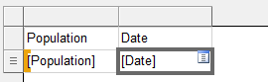

1. Add a Group, by Right Clicking on (Details) under Row Group, Add Group > Parent Group...

Dialogue Box - Tablix Group: Group by: Country, Tick "Add group header"

1. Now Delete the newly created column, making sure you select to delete the column only not the group
2. Delete the column header row and add the Country field in the blank Row (click on the table icon that appears when hovering over the field), can also Merge the cells by right clicking as well
3. Add a new Row between the two rows, by Right Clicking (Details) under Row Groups, Add Total > Before
4. In the new row add the row headers, Should be left with something like this:

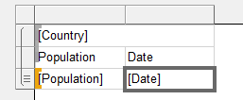

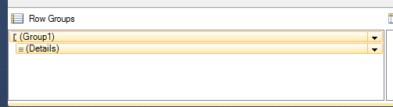

1. Switched over to the Form.cs [Design], Added a ReportViewer from the ToolBox, Choose the newly created report
2. Preview of the Final Solution was as follows

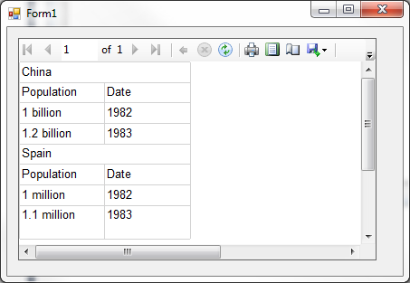

Next steps would be to update the formatting of the report